Introduction to informatics

Homework2: Loop structures

### Exercise 1:

Write a program that:

1. ask the user if he wants to quit the program? If yes, the user must enter the value 0, otherwise, he must type on any other digit.
2. if the user enters the value 0, the program stops.
3. If not, the program repeats by returning to step 1.
4. 编写一个程序：
5. 询问用户是否想退出该程序？如果是，用户必须输入值0，否则，他必须在任何其他数字上输入。
6. 如果用户输入的值为0，则程序将停止。
7. 如果没有，则该程序将重复运行，并返回到步骤1。

Answers

### 

### Exercise 2:

The goal of this game is to make a player (for example the classmate sitting next to you) to guess a number of your choice which he do not know. Using the while/do..while statements do:

1. You will initialize a ”secret” number (between 1 and 100) with a value that you code ”hard” in your program.
2. Your program will then ask the player to guess this number.
3. At each attempt, the program will have to say ”bigger” or ”smaller” or ”won!”. The loop stops when the number has been found. Whatever the case, the program must display the number of attempts used to guess the number:
   1. 1 attempt: accuse the user of cheating or paranormal clairvoyance and advise him to play the lottery.
   2. between 2 and 5 attempts: warmly congratulate the user
   3. between 6 and 9 attempts: tell the user that it as not bad
   4. 10 attempts: tell the user; it was just right
   5. more than 10 attempts, tell the user; he’s a big loser;-)
4. repeat the questions 1 to 3 by using for loops

Answers

上次做过了

### *Exercise 3:*

A number is said to be perfect when it is equal to the sum of its dividers (1 is considered a divisor but not the number itself).

1. With your neighbour, determine an algorithm to test whether a number is perfect or not.
2. Write a function called isPerfectNumberthat that determines whether a number is perfect or not. This function returns 1 (to mean true) if the given number in parameter is actually perfect and 0 otherwise.
3. Then test it by calling it from your main function with the values: 6, 8, 17, 1.
4. Edit the main function to print among the first 10,000 integer numbers those that are perfect.

当一个数字等于它的因数的和（1被认为是一个除数，但不是数本身）时，就说它是完美的。

与你的邻居一起，确定一个算法来测试一个数字是否完美。

写一个名为完美数字的函数，它决定一个数字是否完美。如果参数中的给定数字实际上是完美的，则此函数返回1(均值为true)，否则为0。

然后用主函数的值6、8、17、1调用它来测试它。

编辑主功能，在前10,000个整数中打印那些完美的整数。

Answers

### 

### 

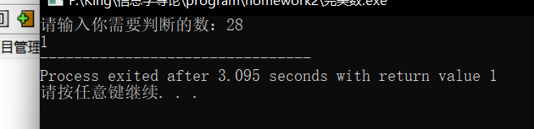

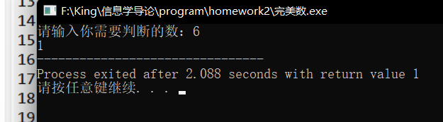

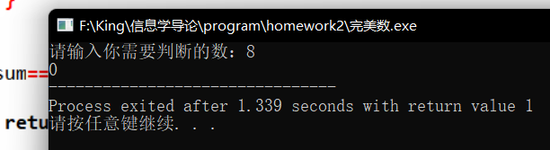

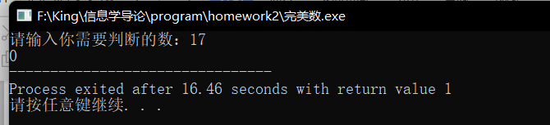

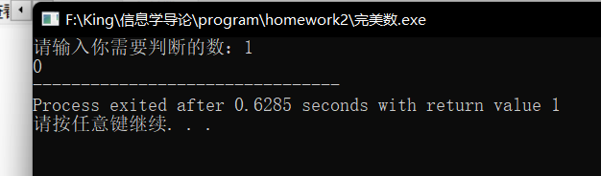

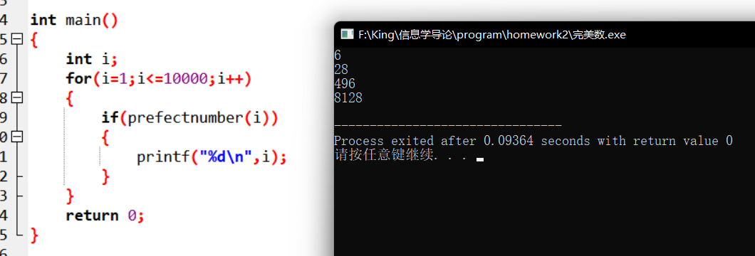

### Exercise 4:

It is about writing two programs - each with a different algorithm- that display all even positive integers lower or equal to 100:

1. the first using the modulo operator (”%”) and a test.
2. the second using an increment step of 2 (take care about the initialisation value of the loop’s variable).

Answers

### 

### Exercise 5:

Write a program to take a l number of rows and a c number of columns, then perform a ”star frame” of l rows per c columns. For example, for l= 5 and c= 10, the program will display:

编写一个程序，取1个行数和c个列数，然后执行每c行1个行的“星形帧”。例如，对于l=5和c=10，该程序将显示：

**\* * * * * * * * * \***

**\* \***

**\* \***

**\* \***

**\* * * * * * * * * \***

Answers

